TRIBHUVAN UNIVERSITY
PATAN MULTIPLE CAMPUS
PATANDHOKA, LALITPUR

SUBJECT: DATA STRUCTURES AND ALGORITHMS (BIT 201)

SUBMITTED BY | SUBMITTED TO
NAME: SURESH DAHAL
ROLL NO.: 23
CLASS: BIT – II/I | ………………………...
DATE: 2081-08-28 | CHECKED BY

1. Write a program to form a sparse matrix and print all the non-zero elements with their location address.
Algorithm
- Start.
- Take input for the dimensions of the matrix (rows and columns).
- Initialize the matrix with user input for each element.
- Traverse the matrix to identify non-zero elements. For each non-zero element, store its value along with its row and column indices.
- Print all non-zero elements along with their row and column indices.
- Stop.

Example
Consider the following 3x3 matrix:
Matrix:
1 0 0
0 0 5
0 7 0
The non-zero elements are:
- 1 at (0, 0)
- 5 at (1, 2)
- 7 at (2, 1)

Program
#include <stdio.h>
int main() {
int rows, cols;
printf("Enter the number of rows: ");
scanf("%d", &rows);
printf("Enter the number of columns: ");
scanf("%d", &cols);
int matrix[rows][cols];
printf("Enter the matrix elements row by row:\n");
for (int i = 0; i < rows; i++) {
for (int j = 0; j < cols; j++) {
scanf("%d", &matrix[i][j]);
}
}
printf("\nNon-zero elements and their positions:\n");
for (int i = 0; i < rows; i++) {
for (int j = 0; j < cols; j++) {
if (matrix[i][j] != 0) {
printf("Element: %d at Position: (%d, %d)\n", matrix[i][j], i, j);
}
}
}
return 0;
}

Output
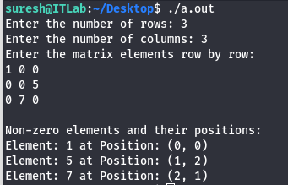

Conclusion
Hence we have written a program to form a sparse matrix and return all non-zero elements with their location address.
2. Define recursion with suitable example. Write algorithm and program with output of the following:
a. Calculate factorial for n integer number
b. Prime number checking
c. Fibonacci series
d. Tower of Hanoi

Theory: Recursion is a programming technique in which a function calls itself to solve a smaller instance of the same problem. This process continues until a base condition is met, which stops further recursive calls. Recursion is commonly used for problems that can be broken into similar sub-problems, such as factorial calculation, Fibonacci sequence, and solving the Tower of Hanoi.
For example, we can find factorial of a number using recursion as:

int factorial(int n) {
if (n == 0 || n == 1) {
return 1; // Base case
} else {
return n * factorial(n - 1); // Recursive call
}
}

a. Calculate factorial for n integer number
Algorithm
- Start
- Define a recursive function factorial(n).
If n == 0 or n == 1, return 1.
Otherwise, return n * factorial(n – 1).
- Take input n from the user.
- Call the recursive function to compute the factorial of n.
- Display the result.
- Stop.

Example
Consider we have to find the factorial of 3
3! = 3*2!
2! = 2*1!
1! = 1
So, 3! = 3*2*1 = 6
Program
#include <stdio.h>
int factorial(int n) {
if (n == 0 || n == 1) {
return 1; // Base case
} else {
return n * factorial(n - 1); // Recursive call
}
}
int main() {
int n;
printf("Enter a number to calculate its factorial: ");
scanf("%d", &n);

if (n < 0) {
printf("Factorial is not defined for negative numbers.\n");
} else {
printf("Factorial of %d is %d\n", n, factorial(n));
}

return 0;
}
Output
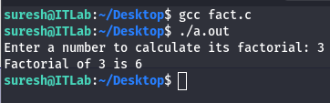

Conclusion
Hence we have used the recursion to find the factorial of the given integer n.

b. Prime number checking
Algorithm
- Start.
- Define a recursive function isPrime(n, i).
If n <= 2, return n == 2.
If n % i == 0, return false
If i * i > n, return true.
Otherwise, call isPrime(n, i + 1).
- Take input n from the user.
- Call the recursive function to check if n is prime.
- Display the result.
- Stop.

Example
Consider that we have to check whether 5 is prime or not.
5 % 2 = 1, not prime
2*2 > 5 = false, not prime

5 % 3 = 2, not prime
3*3 > 5 = true, prime
Because, if square of a number is greater than the given number and it doesn’t divide the given number, the given number is prime.

Program
#include <stdio.h>
#include <stdbool.h>
bool isPrime(int n, int i) {
if (n <= 2) {
return (n == 2);
}
if (n % i == 0) {
return false;
}
if (i * i > n) {
return true;
}
return isPrime(n, i + 1);
}

int main() {
int n;
printf("Enter a number to check if it is prime: ");
scanf("%d", &n);

if (n <= 1) {
printf("%d is not a prime number.\n", n);
} else if (isPrime(n, 2)) {
printf("%d is a prime number.\n", n);
} else {
printf("%d is not a prime number.\n", n);
}

return 0;
}

Output
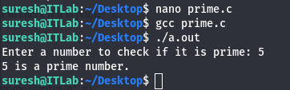

Conclusion
Hence we have used recursion to check whether the given number is prime or not.

c. Fibonacci series
Algorithm
- Start.
- Define a recursive function fibonacci(n).
If n == 0, return 0.
If n == 1, return 1.
Otherwise, return fibonacci(n - 1) + fibonacci(n - 2).
- Take input n from the user.
- Use a loop to compute and display the Fibonacci series up to n terms.
- Stop.

Example
Consider we have to find first 5 Fibonacci numbers.
The first two cases will be f0 = 0, f1 = 1
Then, the third term f2 = f(2-1) + f(2-2)
i.e. f2 = f1 + f0 = 0+1 = 1
Similarly, f3 = f2+f1 = 1+1 = 2
and f4 = f3+f2 = 3

So, the first 5 fibonacci series would be: 0 1 1 2 3

Program
#include <stdio.h>

int fibonacci(int n) {
if (n == 0) {
return 0;
} else if (n == 1) {
return 1;
} else {
return fibonacci(n - 1) + fibonacci(n - 2);
}
}

int main() {
int n;
printf("Enter the number of terms in the Fibonacci series: ");
scanf("%d", &n);

printf("Fibonacci series up to %d terms:\n", n);
for (int i = 0; i < n; i++) {
printf("%d ", fibonacci(i));
}
printf("\n");

return 0;
}

Output
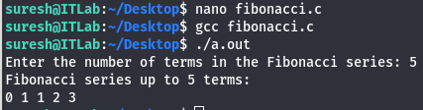

Conclusion
Hence we have implemented a program to find fibonacci numbers using recursion.

d. Tower of Hanoi
Algorithm
- Start.
- Define a recursive function towerOfHanoi(n, source, target, auxiliary).
if n == 1, move the disk from source to target.
Otherwise:
Call towerOfHanoi(n - 1, source, auxiliary, target).
Move the disk from source to target.
Call towerOfHanoi(n - 1, auxiliary, target, source).
- Take input n (number of disks).
- Call the recursive function to solve the problem.
- Stop.

Example
Consider we have 3 disks placed in ascending order in peg A, there are 3 pegs A, B, C and we have to transfer all 3 disks from peg A to peg C following rules of ToH.
The following steps would be involved:
Disk 1 moved from A to C
Disk 2 moved from A to B
Disk 1 moved from C to B
Disk 3 moved from A to C
Disk 1 moved from B to A
Disk 2 moved from B to C
Disk 1 moved from A to C

Program
#include <stdio.h>

void towerOfHanoi(int n, char source, char target, char auxiliary) {
if (n == 1) {
printf("Move disk 1 from %c to %c\n", source, target);
return;
}
towerOfHanoi(n - 1, source, auxiliary, target);
printf("Move disk %d from %c to %c\n", n, source, target);
towerOfHanoi(n - 1, auxiliary, target, source);
}

int main() {
int n;
printf("Enter the number of disks: ");
scanf("%d", &n);
printf("Steps to solve Tower of Hanoi with %d disks:\n", n);
towerOfHanoi(n, 'A', 'C', 'B');
return 0;
}
Output
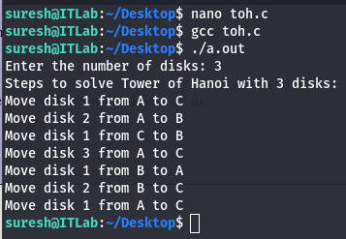

Conclusion:
Hence we have used recursion to implement Tower of Hanoi algorithm.

